Smart Complaint Management System

Developed by:Gowthami Reddy
Technologies:React (Vite), Spring Boot,H2, Tailwind CSS, Daisy UI

1. Introduction
The Smart Complaint Management System is a web-based application that allows users to register complaints and track their status. The system includes an admin panel where administrators can view and update complaint statuses efficiently.
2.Objectives
• To provide an easy interface for users to submit complaints
• To allow admin to manage complaints efficiently
• To maintain transparency in complaint resolution
• To build a full-stack application using modern technologies
3. Technologies Used
Frontend: React (Vite), Tailwind CSS, DaisyUI
Backend: Spring Boot
Database: H2 / MySQL
Tools: Postman, VS Code
4. System Architecture
Frontend (React)
↓
Backend (Spring Boot APIs)
↓
Database (H2/MySQL)
5. Features
User:
• Register & Login
• Create Complaint
• View Complaint Status
Admin:
• View all complaints
• Update complaint status (OPEN, IN_PROGRESS, RESOLVED)
6. Screenshots
• Login page
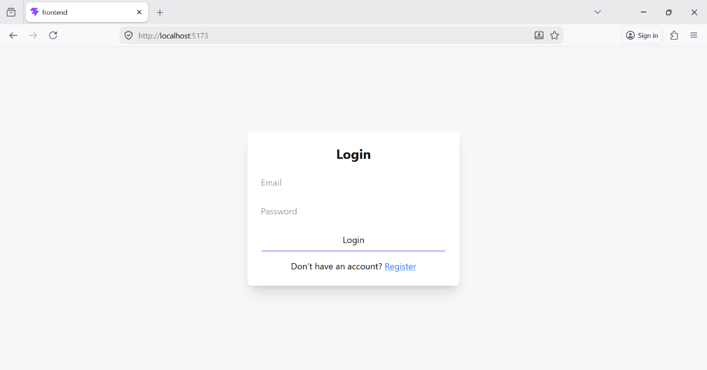
• Register page
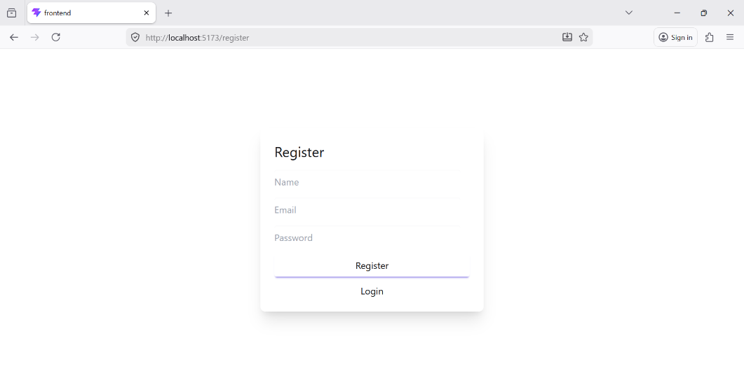
• User Dashboard 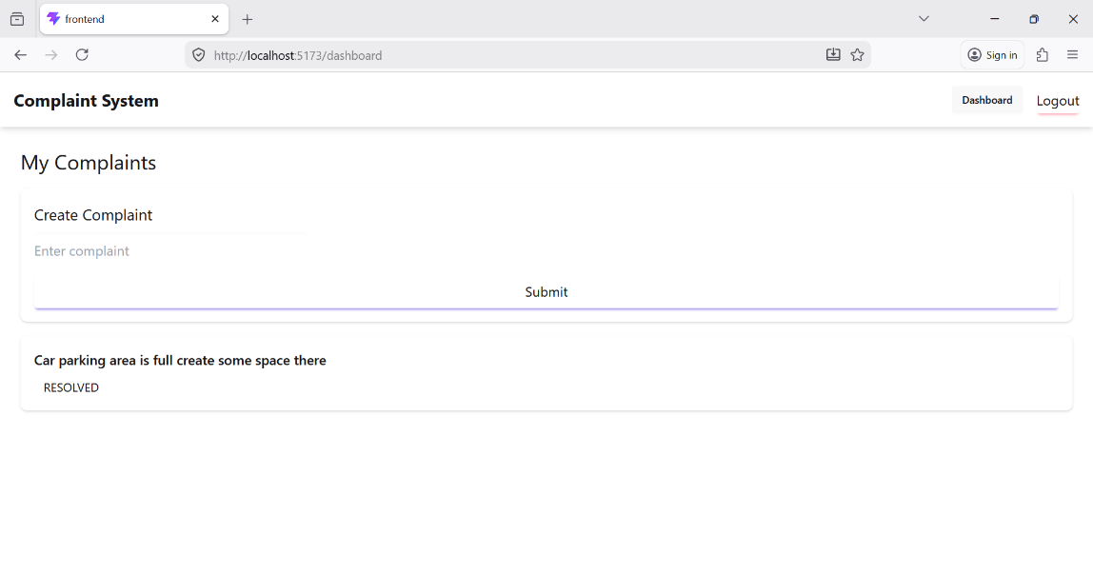

• Admin Dashboard
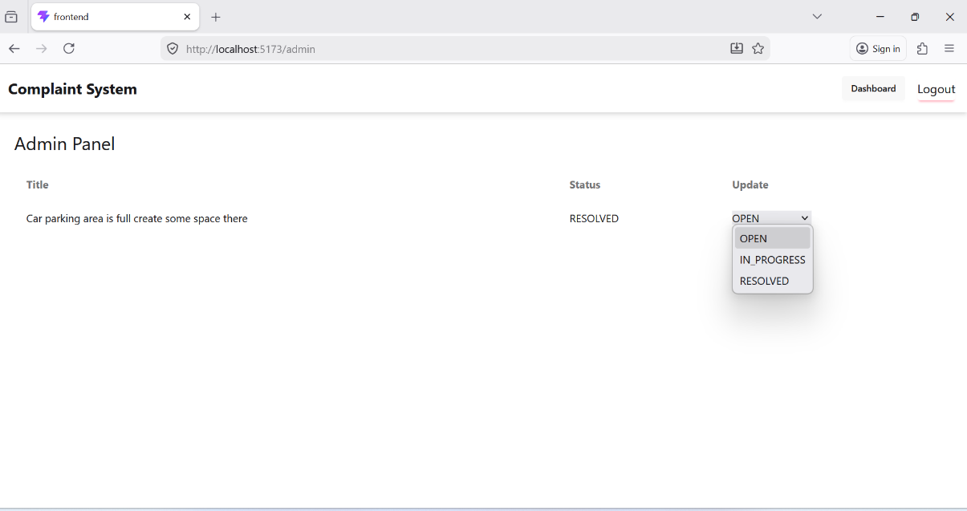
7. API Endpoints
POST /register → Register user
POST /login → Login
POST /complaints → Create complaint
GET /complaints → Get all complaints
GET /complaints/user/{id} → User complaints
PUT /complaints/{id} → Update status
8. Conclusion
This project demonstrates the implementation of a full-stack web application using React and Spring Boot. It provides a real-world solution for complaint management and can be further enhanced with security and scalability features.
9. Future Enhancements
• JWT Authentication
• Email notifications
• File/image upload
• Complaint categories
• Real-time updates

